αIIbβ3, also known as the glycoprotein GPIIb/IIIa (CD41/CD61) complex, is the dominant integrin on platelets and is essential for normal platelet functions. Integrin αIIbβ3 can bind to several arginine-glycine-aspartic acid (RGD)-containing ligands, including fibrinogen, fibrin, von Willebrand factor (vWF), and fibronectin. Of these ligands, fibrinogen is the major ligand. Integrin αIIbβ3 also interacts with the KQAGDV sequence of the fibrinogen γ-chain to cross-link platelets. Each unstimulated platelet presents approximately 50,000–100,000 copies of αIIbβ3 on its surface

**Relationship with other markers and blood parameters**

CD41/61 levels were significantly altered across the No DR and DR groups with the latter having a statistically significant lower values. The microparticle levels of CD41-61 and fibronectin were positively correlated. Among the blood parameters, CD41-61 levels were negatively correlated with ESR, HbA1c, and microalbuminuria with statistical significance albeit with small effect size.

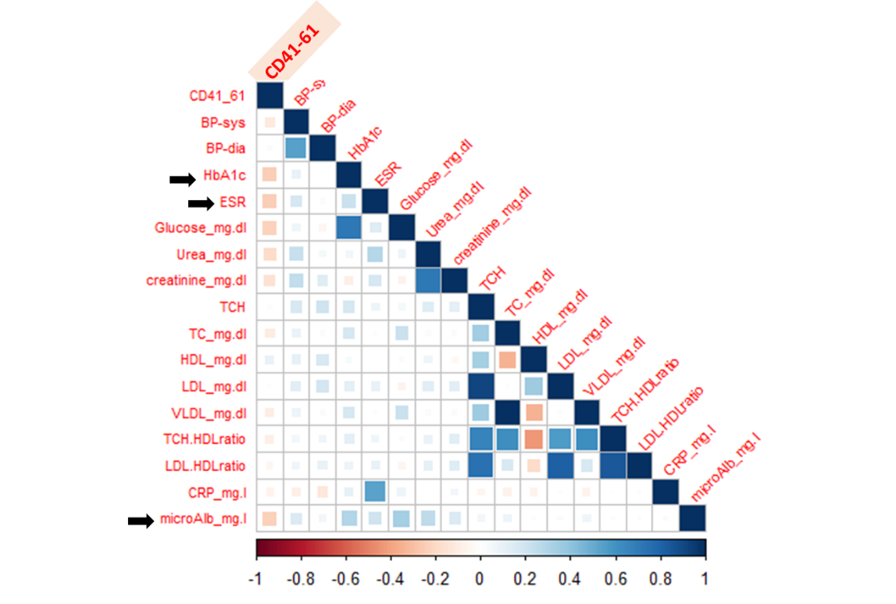

CD41-61 has a moderate negative correlation with HbA1c, ESR and microalbuminuria.

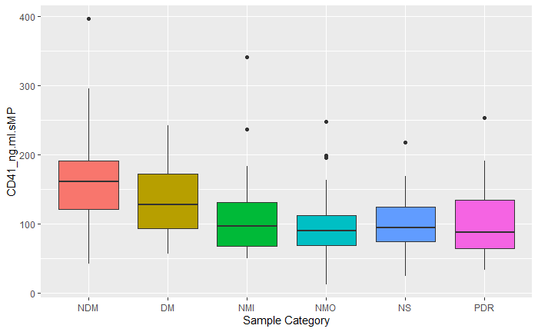

The boxplot compares the level of CD41-61 in the microparticles from six different sample categories and